

Quick Reference Guide

IxNetwork WebUI



Table of Contents

1. Overview 3

1.1. Introduction to IxNetwork 3

1.2. What is IxNetwork Web App 3

1.3. Prerequisites 3

2. Configure BGP from the sample scenarios 4

2.1. IxNetwork Web App login 4

2.2. Create Session 4

2.3. Select sample scenario 5

2.4. Assign Ports 5

2.5. License Settings: 7

2.6. Edit Protocol grid 7

2.7. Run Test/Protocol 8

2.8. Protocol View 8

2.9. Traffic Grid 9

2.10. Statistics View 9

3. Configure OSPF from scratch 11

3.1. Add Test Scenario 11

3.2. Select Protocol 12

3.3. Add Chassis and Port 13

3.4. Add OSPF on IPv4 Protocol 13

3.5. Edit protocol grid 14

3.6. Configure OSPF 15

3.7. Run Test/Protocol 15

3.8. Protocol Actions 16

3.9. Add Traffic item 17

3.10. Edit packet and setup flow groups 18

3.11. Start Traffic 18

3.12. Traffic actions 19

3.13. View Statistics 19

4. Configure a Test scenario using config file 20

4.1. Upload the Config File 20

4.2. Save and Clear the configuration 20

5. Other Utilities 21

5.1. IxNetwork API Browser 21

6. References 22

7. Support 22

# Overview

This reference guide describes the IxNetwork Web application and its usage. It helps IxNetwork test Engineers to configure Ixia test equipment with minimal efforts.

## Introduction to IxNetwork

* + - IxNetwork is a comprehensive network infrastructure performance testing solution. It scales to handle powerful devices and very large networks, from routing and switching to data center ethernet and software defined networking.
    - IxNetwork is specifically targeted for the performance and functionality testing of high- speed, high-capacity routers, switches and other network infrastructure elements.
    - Provides a powerful, yet easy-to-use, graphical user interface (GUI) that you can use to configure and run complex tests. The user interface comes in two varieties; a windows based application and a web based application. It is the web app that is the focus of this document.
    - Offers the flexibility to customize the configuration settings to meet a wide range of requirements for testing complex network topologies, consisting of thousands of routing or switching devices.
    - IxNetwork is capable of emulating millions of routes and addressable hosts within a single topology. It provides the ability to customize millions of traffic flows using the emulated hosts to stress the data plane performance.
    - Creates sophisticated configurations using powerful wizards and grid controls in the UI.
    - Capable of reporting comprehensive protocol status and detailed per-flow traffic performance metrics based on a wide array of tracking options.

## What is IxNetwork Web App

* + - IxNetwork Web App is a web-based client UI for Ixia’s layer 2-3 traffic generation test application, and is most commonly used for testing routing and switching networks.
    - IxNetwork Web App supports multiple concurrent users and sessions, and allows multiple users to access a session, or a user to access multiple sessions simultaneously.
    - IxNetwork Web App has built-in REST API browser that helps users configure the test tool through a UI and then correlate the change directly to REST commands.

## Prerequisites

* + - IxNetwork Version should be 9.00 and above.

# Configure BGP from the sample scenarios

This section demonstrates creating a BGP test scenario from sample scenarios.

## IxNetwork Web App login

* + - Provide IP address of the VM or Chassis in the URL.
    - Enter login credentials and click LOGIN .

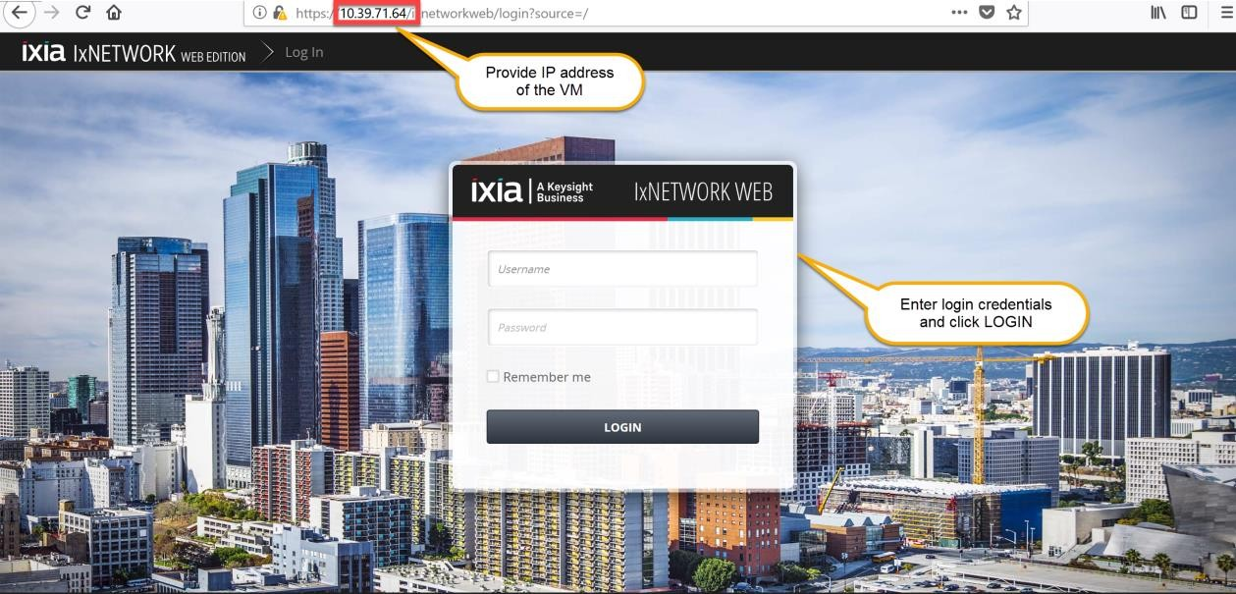

Fig 2.1-Login page

## Create Session

* + - Web App allows user to work with multiple sessions by creating a new session or selecting from the existing sessions.

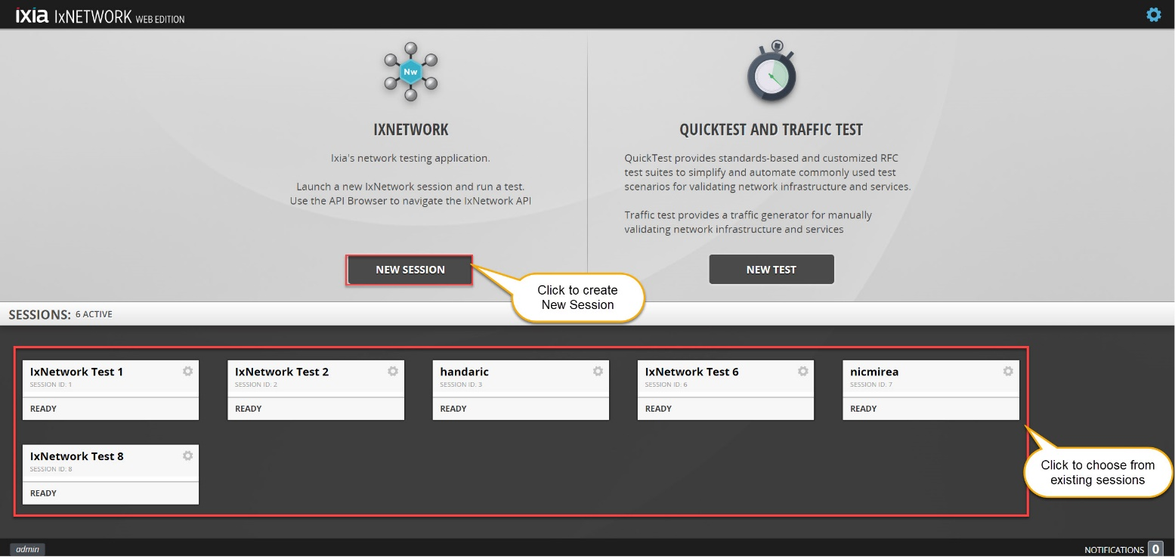

Fig 2.2 Create session window

## Select sample scenario

* + - User can choose the test scenarios from the sample or recent scenarios.

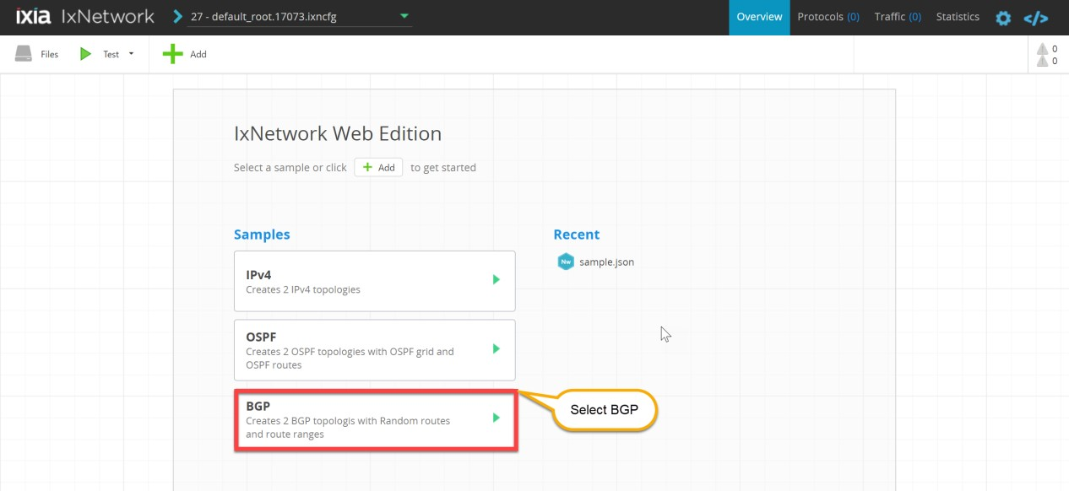

Fig 2.3 Select sample scenario

## Assign Ports

* + - **Select Ports** window allows user to assign port to the topology, Enter chassis IP and choose the available port from the list of ports, different port states are explained in Fig 2.4.2.
    - User can perform **Select/Unselect**, **Unassign selected ports** and **Remove selected ports** as shown in Fig 2.4.3.
    - User can edit **L1 Settings** as shown in Fig 2.4.4.

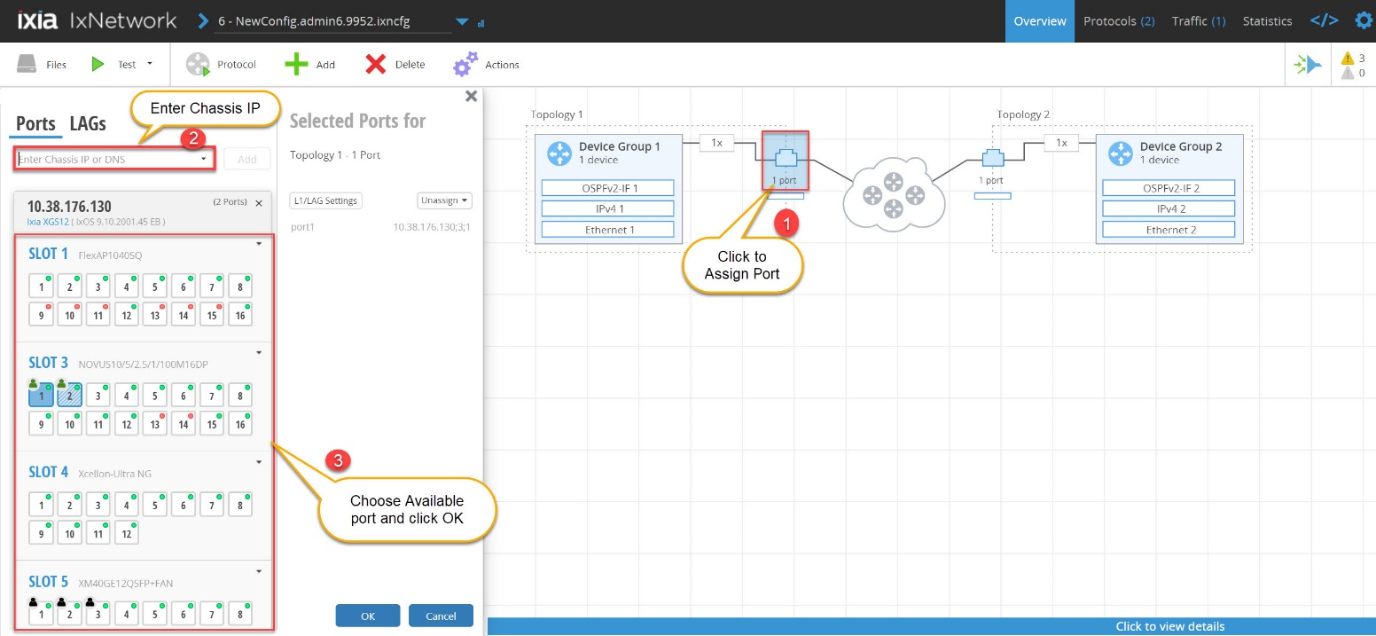

Fig 2.4.1 Assigning and connecting Port

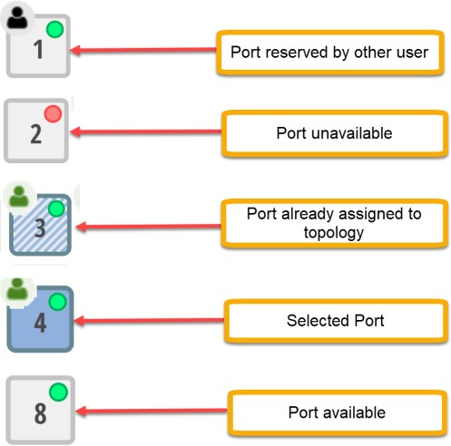

Fig 2.4.2 Different port states

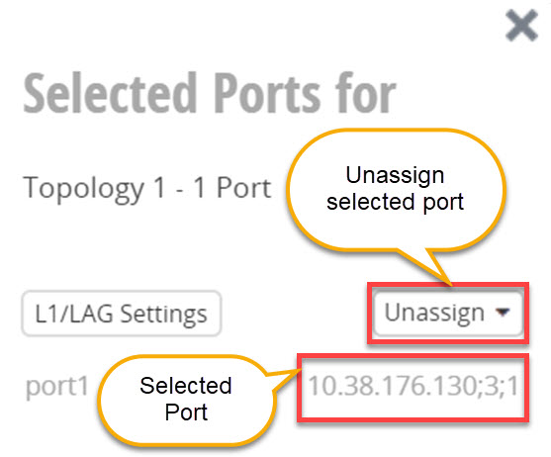

Fig 2.4.3 Port unassign options

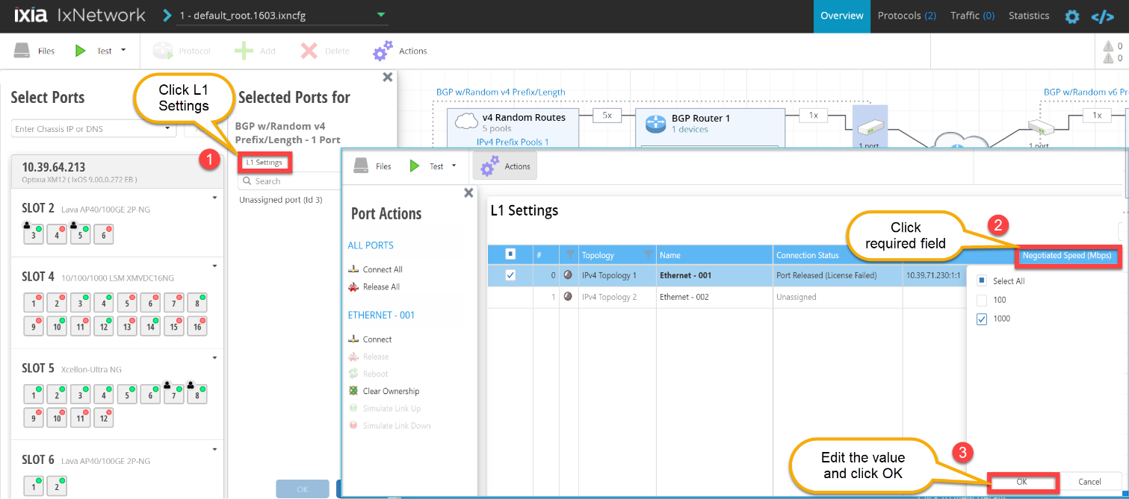

Fig 2.4.4 L1 Settings

## License Settings:

* + - User can edit License settings from **Settings** page.

Fig 2.5 License Settings

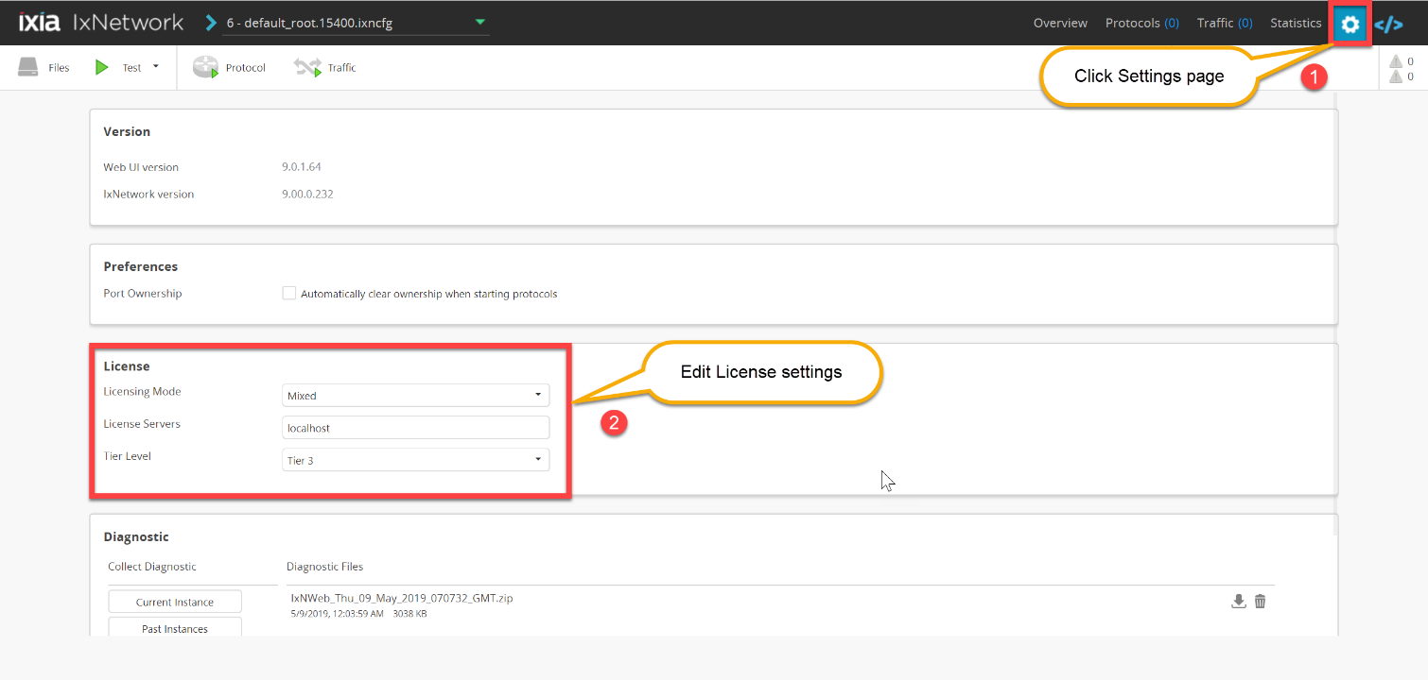

## Edit Protocol grid

* + - Edit the required fields from the BGP protocol grid and save the configuration.
    - For example, change the BGP Type as shown in Fig 2.6.

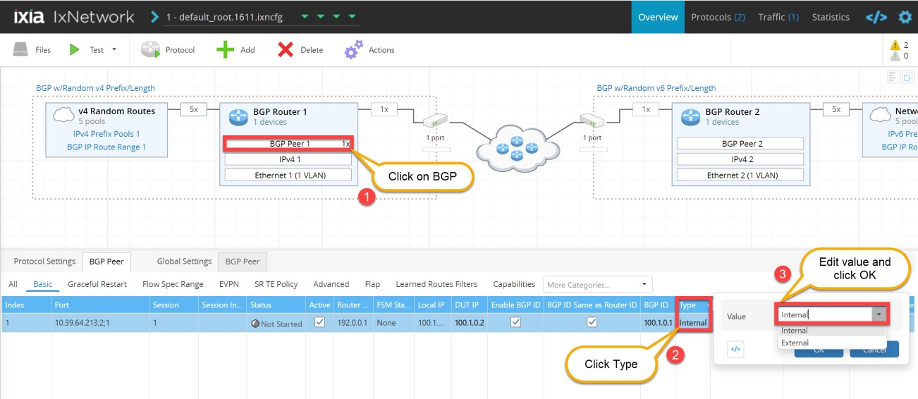

Fig 2.6 Edit BGP Protocol grid

## Run Test/Protocol

* + - Run the Test scenario by clicking on **Test** or **Protocol**.
    - As shown in Fig 2.7.2, observe the ports getting connected and all the protocols getting started, followed by Traffic.

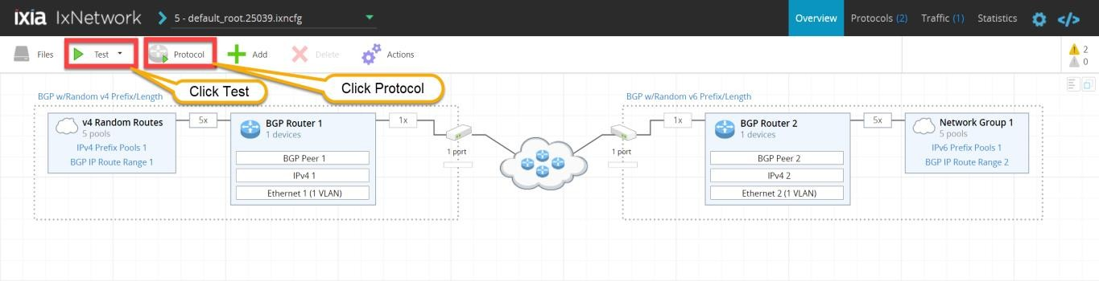

Fig 2.7.1 Run Test/Protocol

Fig 2.7.2 Protocol Status after run Test

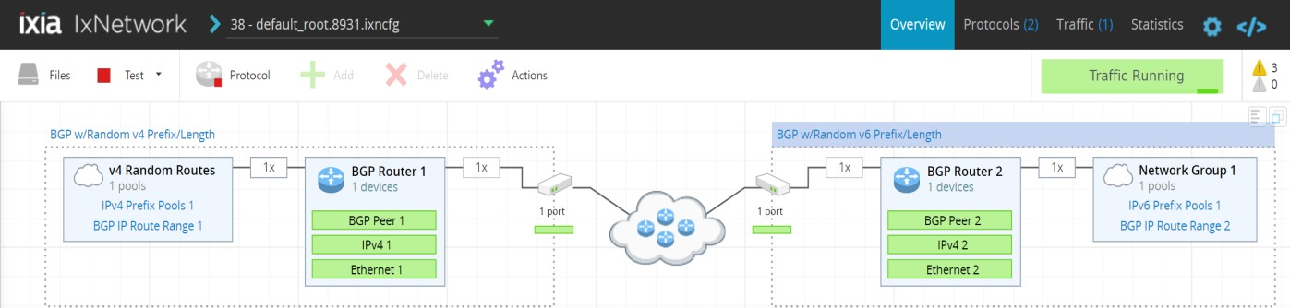

## Protocol View

* + - User can view the details of the protocol in **Protocols** page.
    - User can choose different view options from the drop down list.

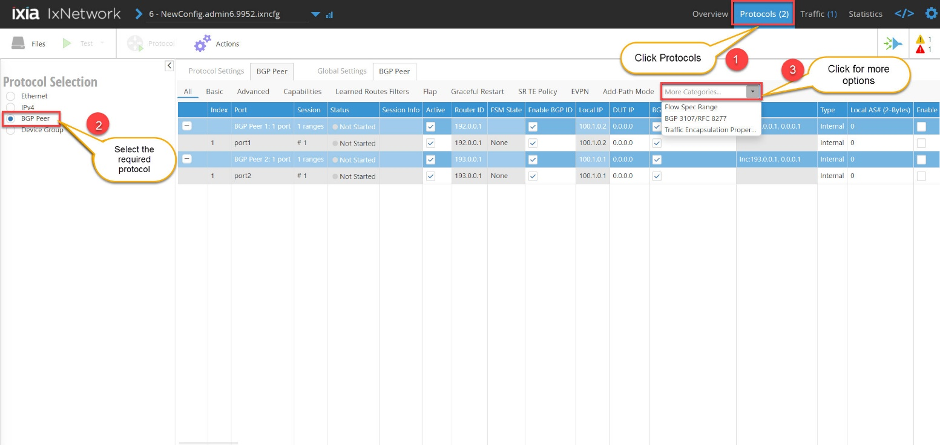

Fig 2.8 Protocol View

## Traffic Grid

* + - **Traffic item** and **flow groups** grids are interactive, user can edit the fields and save the configuration which is shown in detail in section 3.10.
    - Create the flow groups based on the selectable packet fields, osne flow group/high-level stream is created for each selected field.

*Editing the traffic item and setting up the flow group is optional

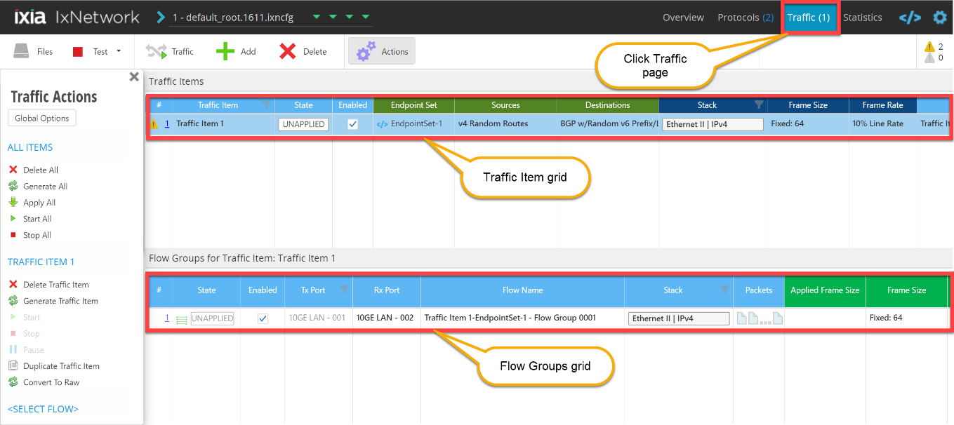

Fig 2.9 Traffic Grid

## Statistics View

* + - User can view the traffic statistics from the **Statistics** page.
    - User can view different statistics like **Port Statistics**, traffic **Flow Statistics** and traffic dashboard as shown in the Figures 2.10.1, 2.10.2 and 2.10.3.

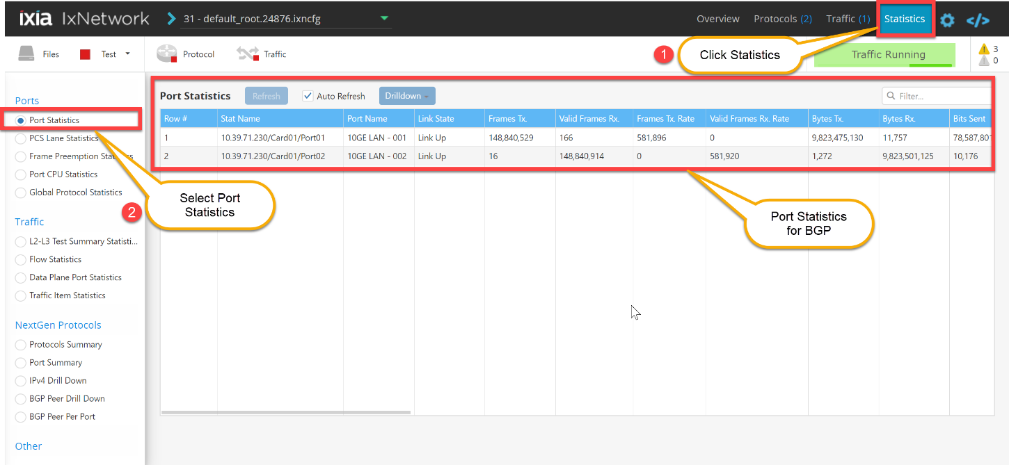

Fig 2.10.1 Port Statistics View

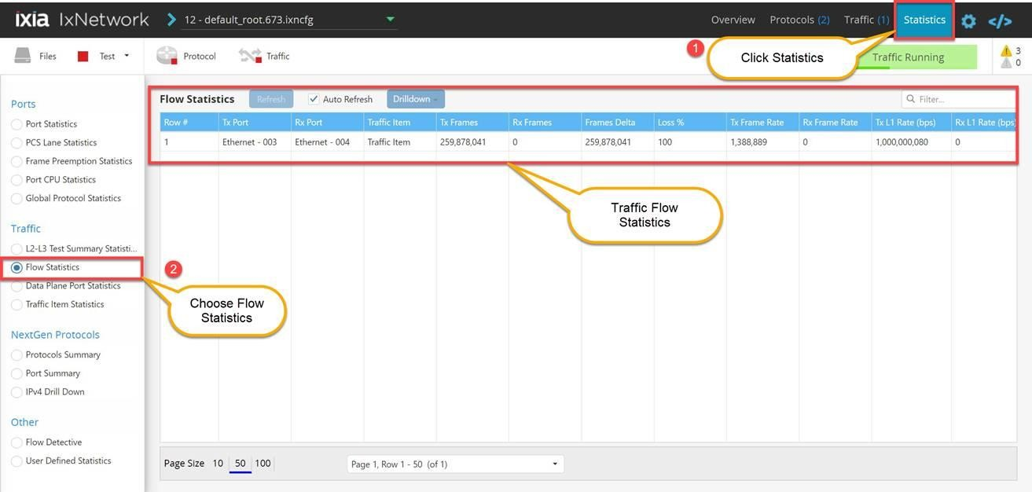

Fig 2.10.2 Traffic Flow Statistics View

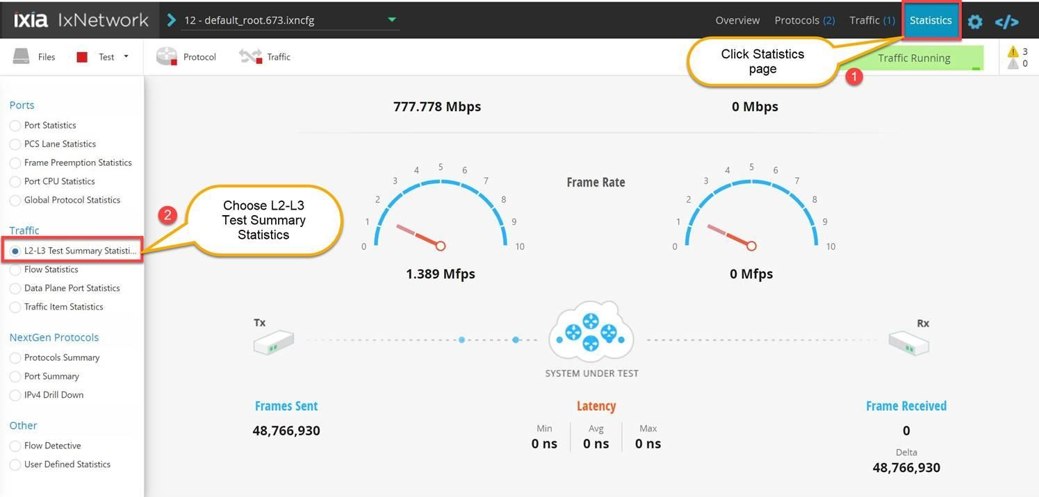

Fig 2.10.3 L2/L3 Traffic Dashboard

# Configure OSPF from scratch

This section walks through a scenario which configures OSPF emulation manually to get the user introduced to most of the basic features of Web App.

## Add Test Scenario

* + - User can add a new test scenario by clicking **Add** from the Overview page.
    - User can also choose an existing scenario from samples or recent list of scenarios.

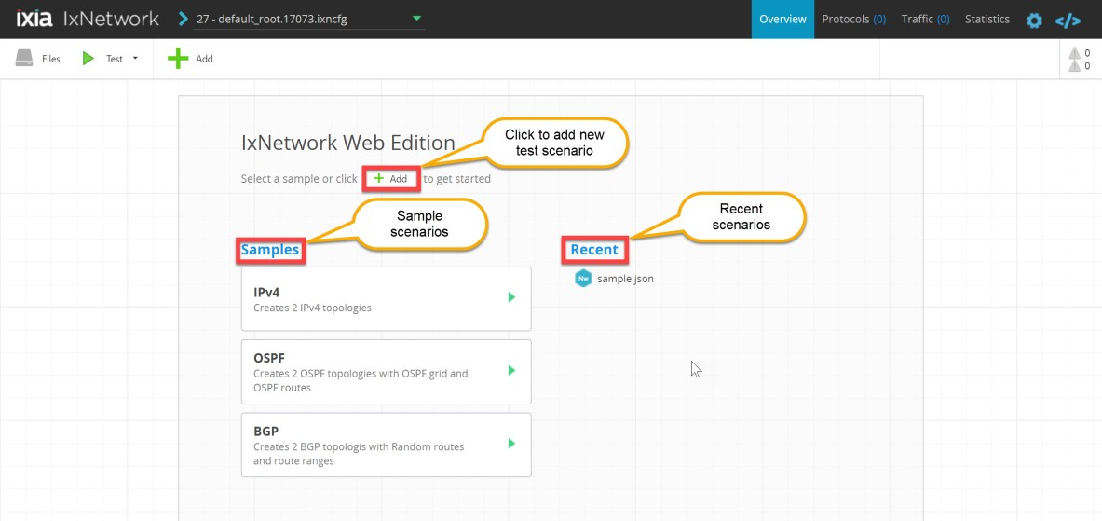

Fig 3.1 Overview page-Create Test scenario

## Select Protocol

* + - The **Select Protocols** window allows user to select protocol from the list of supported protocols, for example IPv4.
    - Scroll down to view all the available protocols.

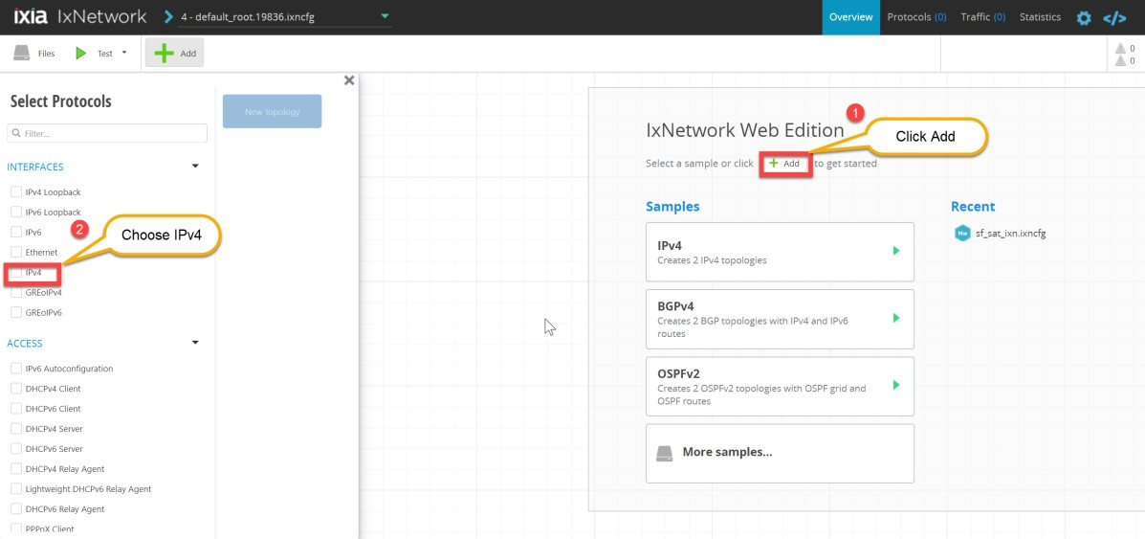

Fig 3.2 Select Protocol

## Add Chassis and Port

* + - The Port selection window allows user to manage ports.
    - After choosing a protocol from the list, **Add Chassis** window pops up to the user, select chassis by entering chassis IP or select chassis from the list of recently used chassis and click **Connect all checked**.
    - Select the available port under the chassis in **Select Ports** window and click **New Topology.**
    - User can add multiple topologies before closing the topology window.

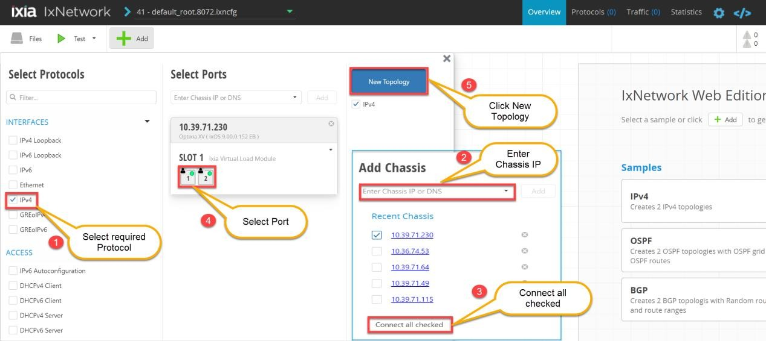

Fig 3.3 Add Chassis and Assign ports

## Add OSPF on IPv4 Protocol

* + - User can add additional topologies, device groups and protocols by clicking **Add** tab.
    - **Select Protocols** window allows user to choose the protocols as shown in Fig 3.4.2.
    - Select OSPF protocol from **ROUTING/SWITCHING** section of **Select Protocols** window.

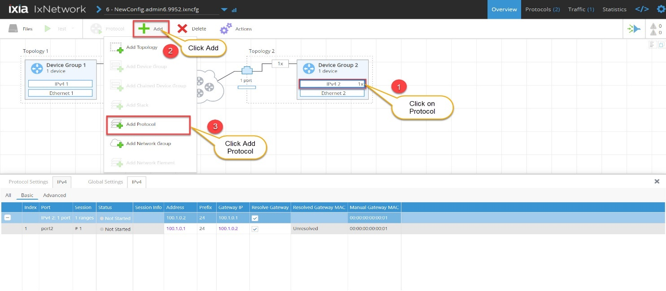

Fig 3.4.1 Add OSPF on IPv4 Protocol

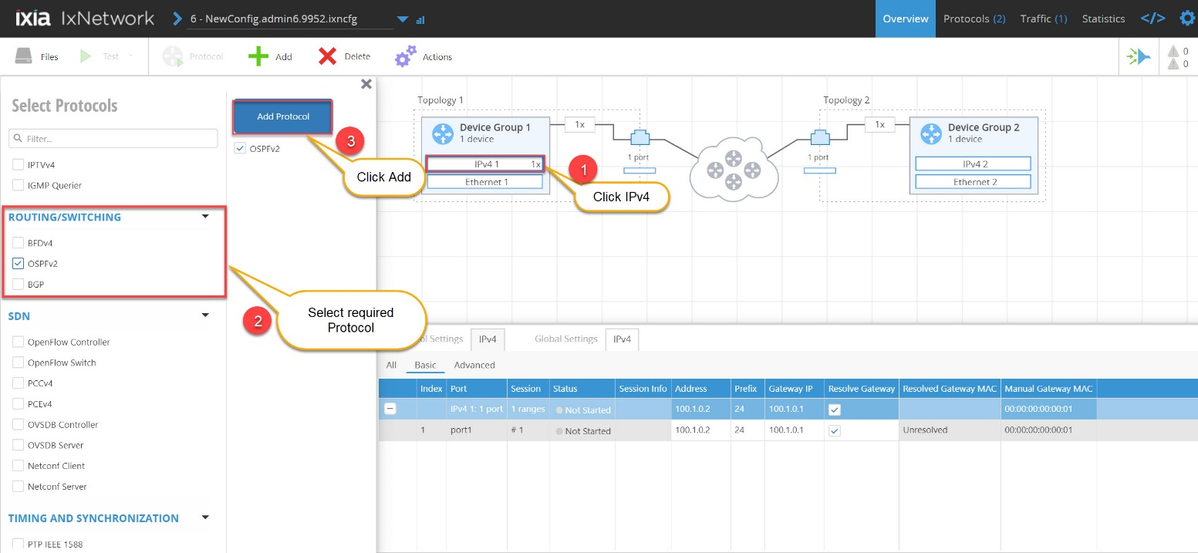

Fig 3.4.2 Select OSPF to add on IPv4

## Edit protocol grid

* + - The interactive protocol grid appears at the bottom of the overview page when particular protocol is selected.
    - Edit the required fields and save the configuration.
    - For example change the address and gateway for IPv4 protocol as shown below.

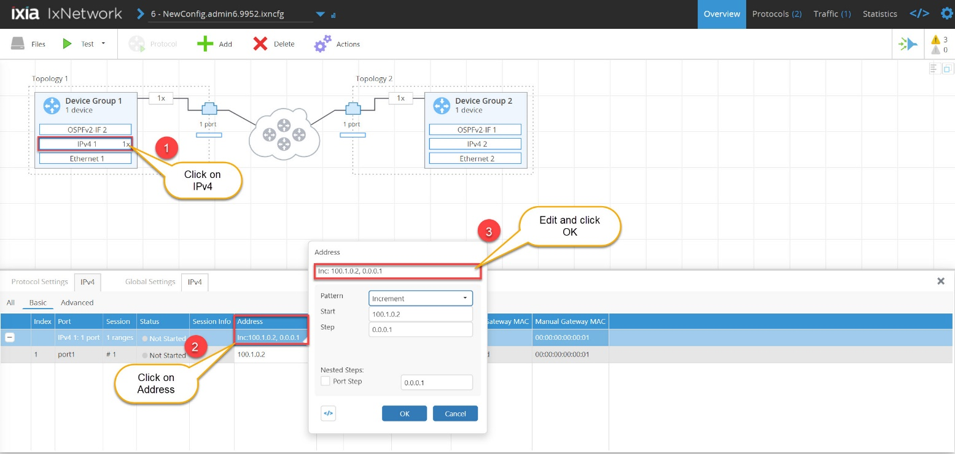

Fig 3.5 Edit Protocol grid

## Configure OSPF

* + - Edit OSPF protocol grid.
    - Change the Network Type to Broadcast/Point to Point.

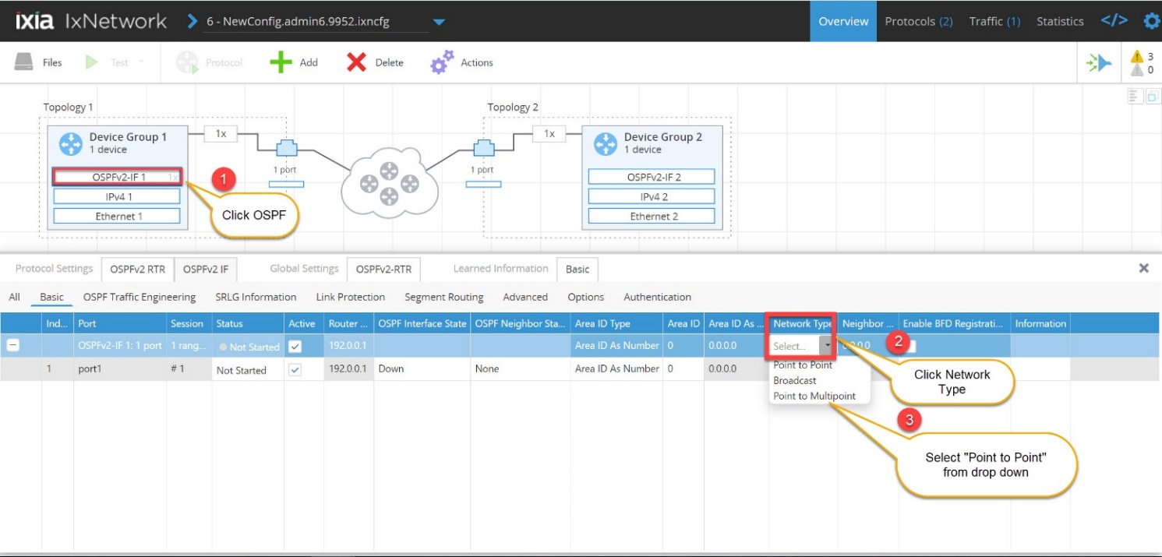

Fig 3.6 Configure OSPF

## Run Test/Protocol

* + - User is provided with two options to run the protocols.
      * **Test** is a new utility which initiates complete test scenario in one shot. It includes connecting to ports and starting protocols followed by starting Traffic.
      * Start **Protocol,** starts all protocols configured in the test session.

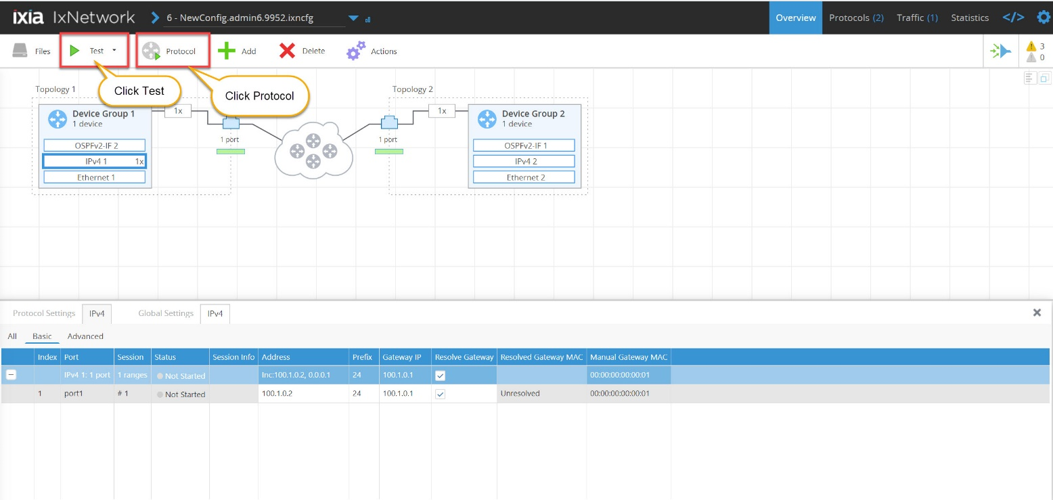

Fig 3.7 Run Test/Protocol

## Protocol Actions

* + - Web App has provision to view details of all the protocols in **Protocols** page.
    - User can choose the required protocol and the category from the drop down.
    - Different protocol actions can be performed by selecting from the list of actions.

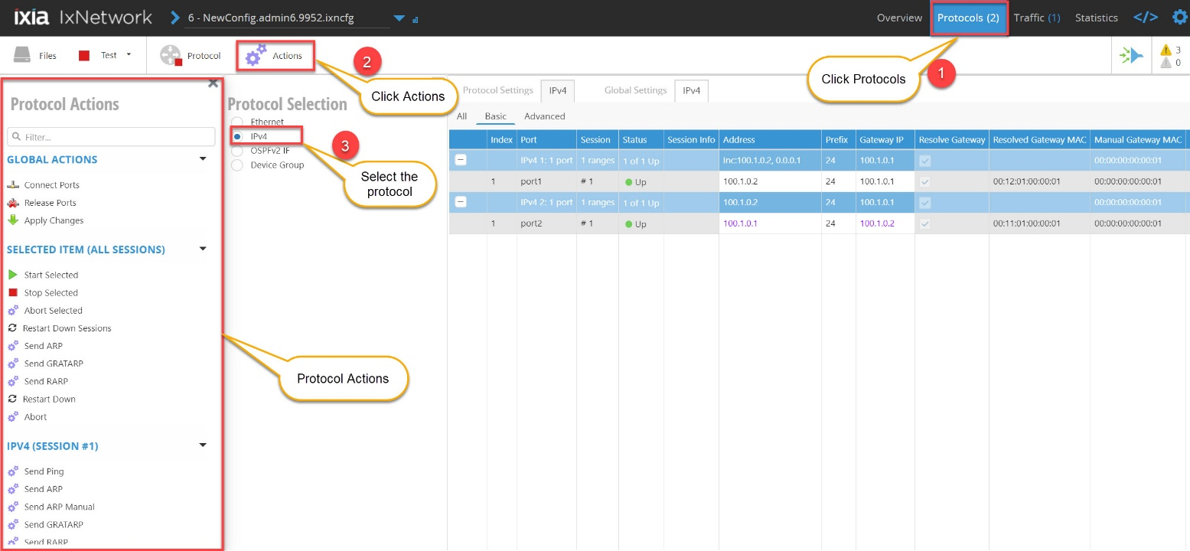

Fig 3.8 Protocol Actions

* + - Select “Learned info Basic” from protocol options to see the OSPF learned information

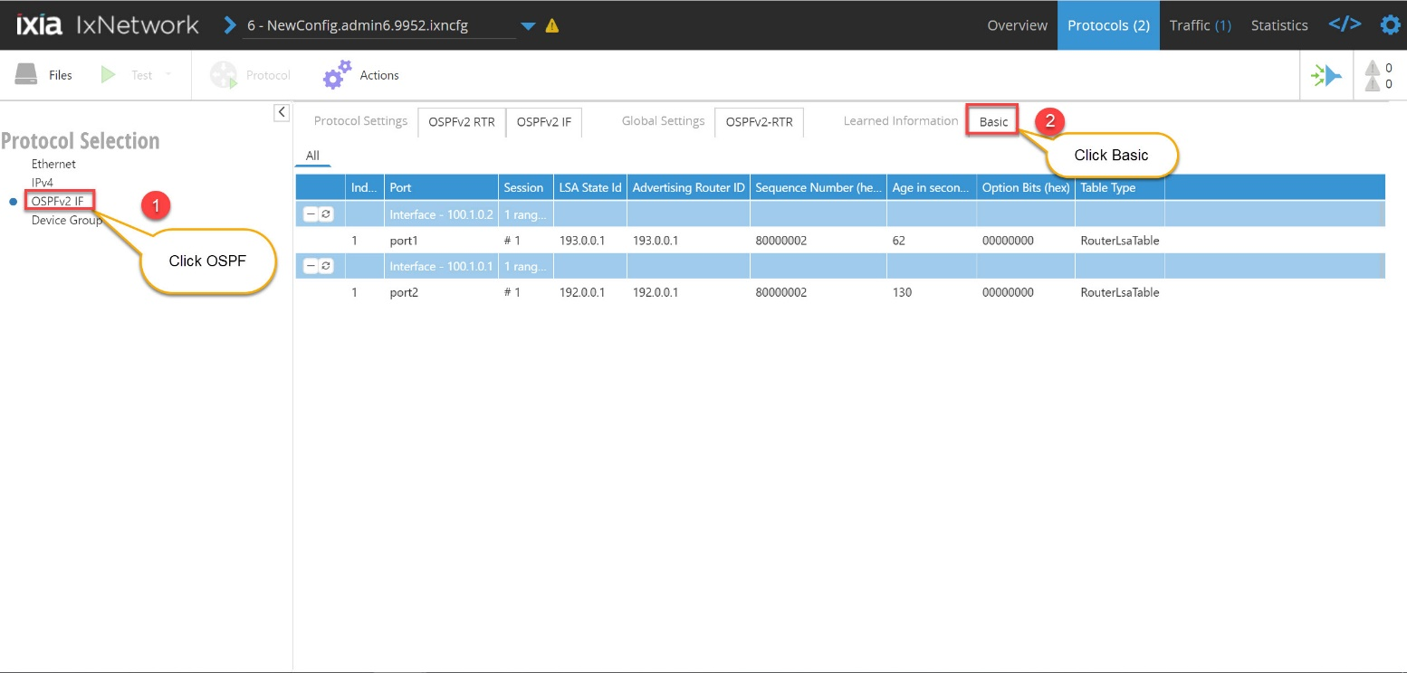

Fig 3.9 OSPF learned info

## Add Traffic item

* + - Configures the traffic streams on the specified ports.
    - Select Traffic type from the dropdown list Ex : IPv4.
    - Choose Source and Destination from **Add Traffic** window.

*Changing Mesh settings is optional

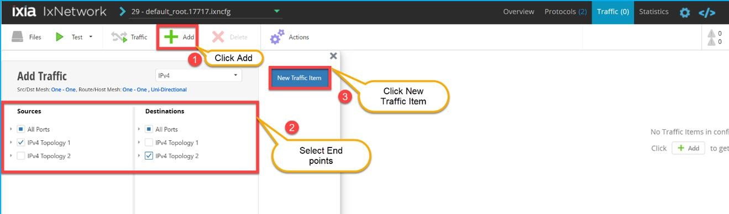

Fig 3.9 Add Traffic item

* + - Add ‘Endpoint Set’ by selecting source and destination by selecting respective topology

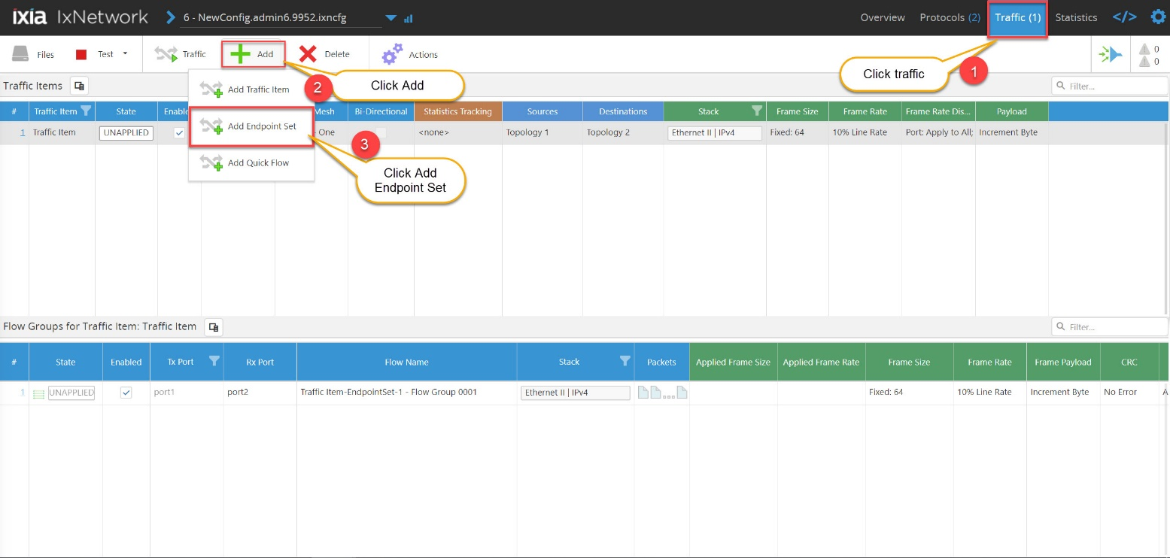

Fig 3.10 Add Endpoint Set

## Edit packet and setup flow groups

* + - Click on **Traffic item** to view flow groups grid.
    - **Traffic Item** and **Flow Groups** grids are interactive, user can edit the fields and save the configuration.
    - Create the flow groups based on the selectable packet fields, One flow group/high-level stream is created for each selected field.

*Editing the traffic item and setting up the flow group is optional

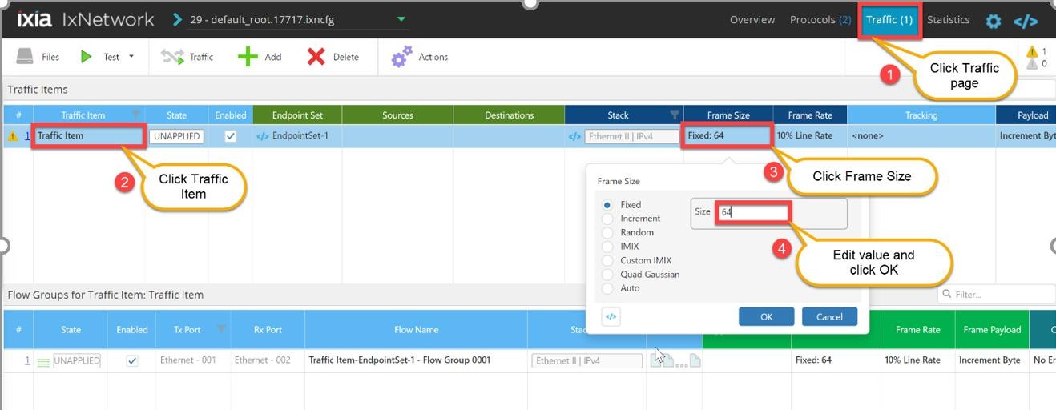

Fig 3.11 Edit Packet and setup flow groups

## Start Traffic

* + - Start the traffic from **Traffic** page.

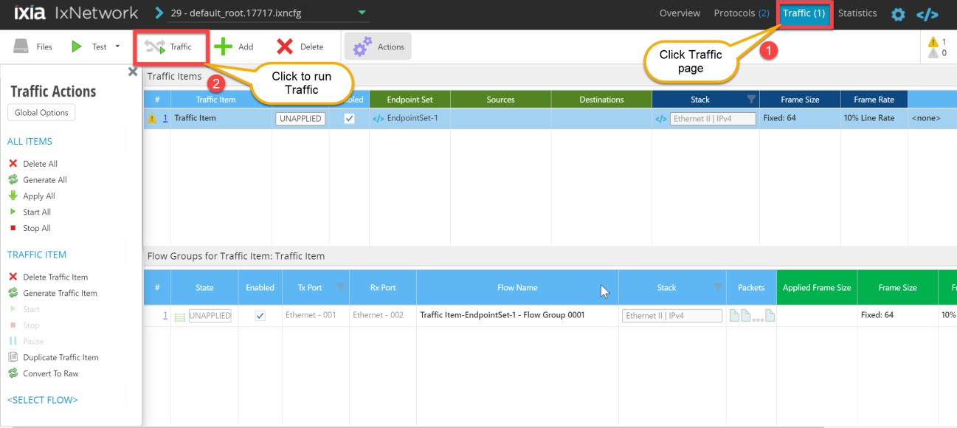

Fig 3.12 Start Traffic

## Traffic actions

* + - Similar to protocol actions, **Traffic Actions** allows user to perform different actions related to traffic.
    - User can perform different traffic actions from the list shown in Fig 3.12

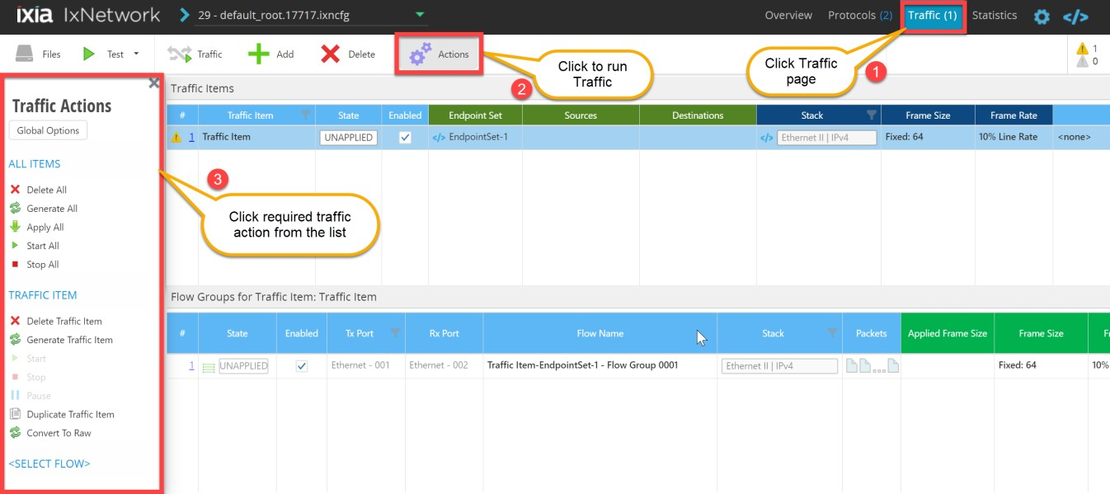

Fig 3.13 Traffic actions

Fig 3.12 Traffic actions

## View Statistics

* User can view traffic statistics from Statistics page.

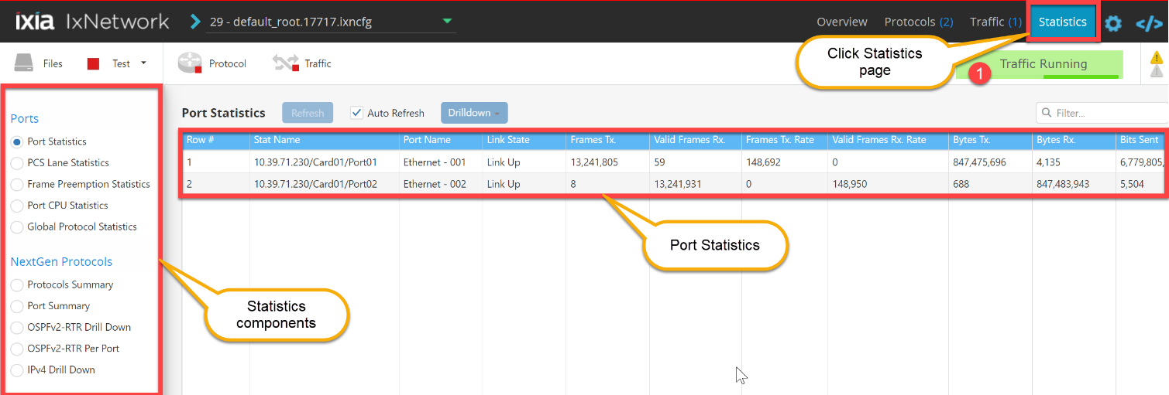

Fig 3.14 View Statistics

# Configure a Test scenario using config file

This section walks through a scenario in which user is allowed to configure a test scenario by uploading ixncfg or json configuration files from **Files** tab, and user can also save the current configuration.

## Upload the Config File

* + - Click **Browse to upload file** from **Files** tab to upload ixncfg config file, for example upload ISIS_L3.ixncfg.
    - After uploading the ISIS_L3.ixncfg, follow the steps from **section 2.4** to **2.10** to bring up the test scenario.

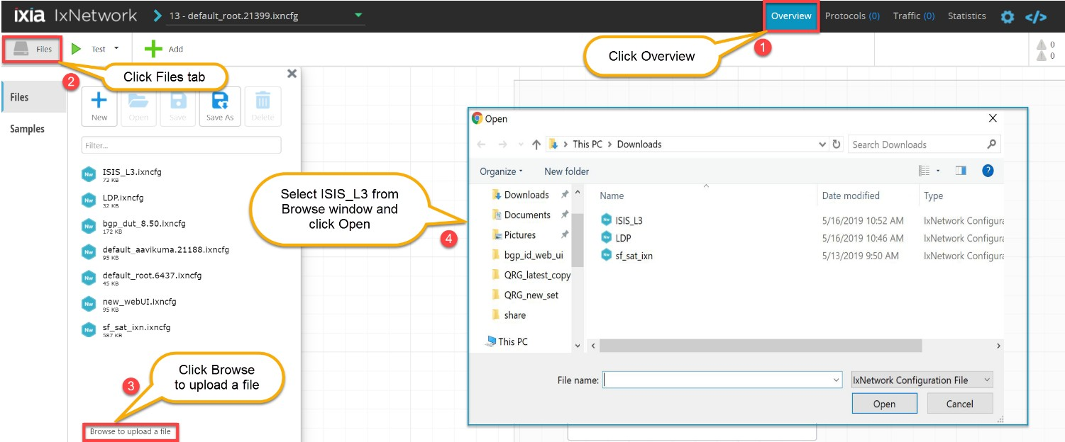

Fig 4.1.1 Upload config file

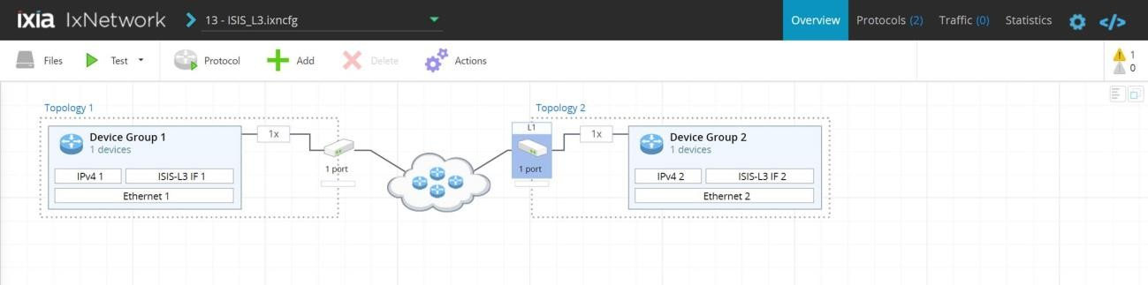

Fig 4.1.2 After uploading ISIS_L3.ixncfg

## Save and Clear the configuration

* + - User can save and clear the current configuration from **Files** tab.

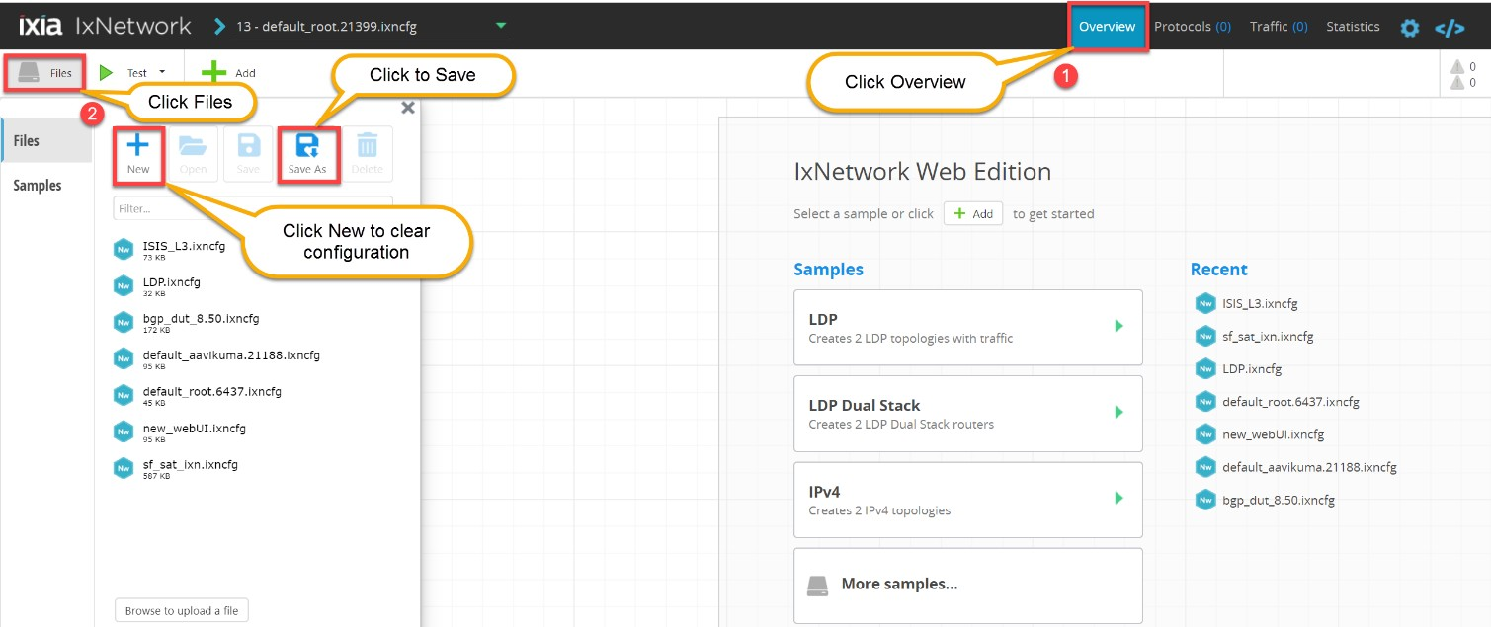

Fig 4.2 Save and Clear Configuration

# Other Utilities

This section covers additional capabilities of Web App.

## IxNetwork API Browser

* + - The main feature of this application is the ability to browse the API data in a hierarchical format. Access each level of the hierarchy with a view of siblings, attributes, execs, errors, and children.

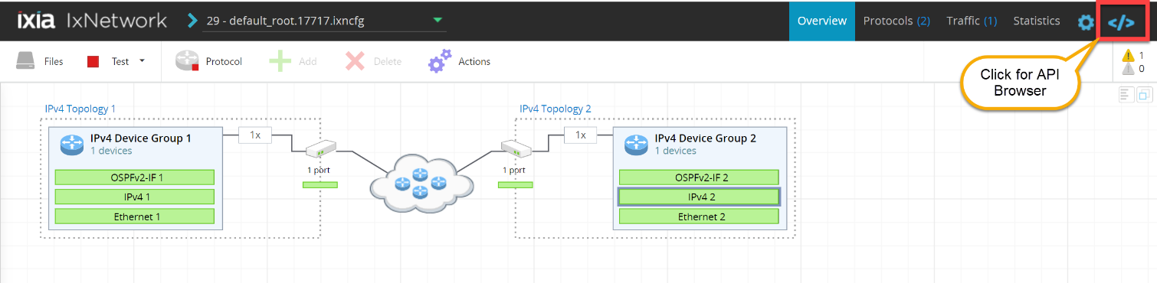

Fig 5.1.1 IxNetwork API documentation link

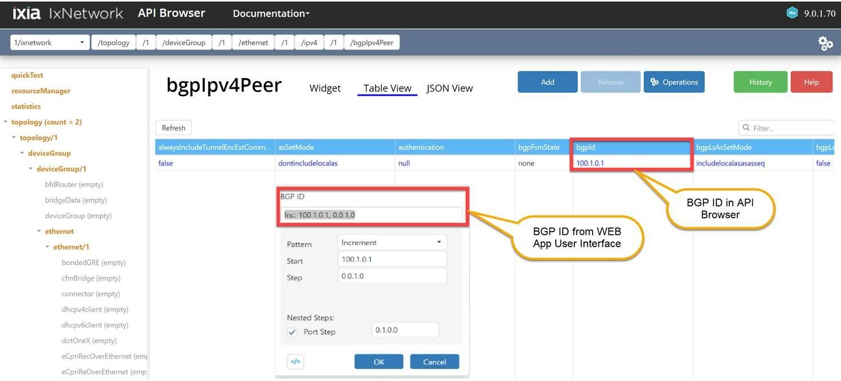

# References

Fig 5.1.2 IxNetwork API Browser

Linux API Server: https://[www.youtube.com/watch?v=qSkgQvhGUeY&t=1s](http://www.youtube.com/watch?v=qSkgQvhGUeY&t=1s)

Ixia Training Tv: <https://www.youtube.com/channel/UCanJDvvWxCFPWmHUOOlUPIQo> Black books:

<https://www.ixiacom.com/resources?field_resource_topic_target_id=271&field_resource_type_> target_id=180&field_industries_target_id=All&combine=&items_per_page=28

# Support

For more information, please visit the Ixia site (<https://support.ixiacom.com/>) For support assistance, please contact ([Support-India@ixiacom.com](mailto:Support-India@ixiacom.com))